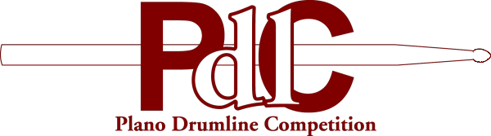 | PLANO DRUMLINE COMPETITION  2200 Independence Parkway  Plano, TX 75075
Press Release
Contact: Michael A. Hernandez  email: michael.hernandez@pisd.edu  Parent Coordinator Name  email: xxxx@xxxx.xxx | FOR IMMEDIATE RELEASE  10 AM CDT, September Date, Year

The 17th Annual Plano Drumline Competition will be held at Clark Stadium beginning at approximately 11:30pm on Saturday, September 27. Clark Stadium is located in Plano, TX, slightly north of Spring Creek Parkway and just west of Central Expressway.

Come out and enjoy some of the premiere drumlines from Texas and surrounding states. Since its inception, the PdlC has been a leading influence in the promotion of drumline performance. This "Sport of the Arts" has gained much momentum in the last 20 years with the PdlC offering high school programs an opportunity to perform, compete, and perpetuate their music and percussion program through their most visible component, the marching percussion section.
Cost is $5 for adults, $3 for middle school students, and $1 for children under the age of 10. Tickets can be purchased at the event.

-End-

